Overview
Welcome to the latest in our series of quarterly newsletters for the Sajag-Nepal project. The purpose of these newsletters is to summarise the breadth and depth of research across the project, highlight outcomes and outputs that we want to share more widely, and draw attention to upcoming activities or milestones.
The last few months have been busy across all parts of the project. In our four case-study palikas, the RAs have now completed four or five periods of field work, and have built up key relationships across different parts of the community. As a result, even with the local elections in May and the changes to the palika- and ward-level government officials, we have been able to make a lot of progress on local understandings of hazard and risk. May and June also saw the installation of the first slope monitoring stations at a couple of sites in Sindhupalchok district, with colleagues from Tribhuvan working closely with team members from Durham, Northumbria, and the Social Science Baha to ensure that the locations were chosen in close collaboration with palika residents and other stakeholders. Together with the developing multi-hazard inventory, this should give us a much clearer national-scale picture.
Work has also moved ahead on monsoon and earthquake planning. In April, Sweata, Alex Dunant, and I met with all of the Humanitarian Country Team clusters, hosted and ably facilitated by the UN RCO. These meetings helped us to understand the timeline of cluster planning around the monsoon and earthquake preparedness plans, and cluster members provided some clear guidance for where some additional scientific information could be useful in helping them to plan. Sihan and Alex have made considerable progress in understanding patterns of monsoon rainfall and in developing a risk model framework that can consider both earthquake and monsoon triggers.
The project team continues to grow. We welcomed Dipak Basnet from the Social Science Baha, who will take over as RA focusing on the Bhote Kosi gaun palika this summer. We are also joined by two new RAs at Tribhuvan, Narawaj Parajuli and Subash Duwadi. Many of the RAs met up at the end of May, hosted by NSET, and we hope that they will be able to meet again more frequently as Covid restrictions continue to ease.
We also, after considerable hard work by Surya and Jimee at NSET, have a formal agreement with the NDRRMA that provides us with a pathway by which the project outcomes can be applied more widely in Nepal. And at long last we have a project website, www.sajag-nepal.org, which I hope everyone will be able to contribute to.
Alex Densmore
SPOTLIGHT ON RESEARCH
As part of our ‘spotlight on research’ section, Tek Bahadur Dong, from Social Sciences Baha Services, took part in our quiz, please read on to find out more!
Q1. Tell us a little bit about you and your background
I was born in Temal Rural Municipality of Kavre district, approximately 65 km away from the capital of Nepal. I left my hometown when I completed my SLC and started work in the tourism industry in Pokhara but left this town when I enrolled in Central Department of anthropology where I completed my Master’s Degree and then Master’s of Philosophy in anthropology. Therefore, I study anthropology.
My research journey begins from 2010, a year after completion of my Master’s Degree and till to date, I have worked in different research organisations and institutions as a research associate, ethnographic field researcher, and research fellow. Some of the key personalities to whom I worked are Dr. Sara Shneiderman and Dr. Mukta S Lama, and I had an opportunity to learn about social inequality and cultural diversities which are now helpful insights to understand different levels of disaster impacts and how vulnerable communities become more vulnerable in post disaster. As part of my career, I have also been working in tourism industry since last two decades and have opportunities to observe various landscape of Nepal.
Q2. What drew you into your research area?
When I visited my hometown just few days after of Gorkha earthquake 2015, I had an opportunity to observe the coping strategies of the local people and how local elites were active in controlling relief materials distributed by different institutions and organisations. A depth level of disaster life and disaster culture were understood when I had joined with my better half when she was completing her ethnographic field work for her MPhil thesis. Being a social anthropologist, I always keen to understand disaster life and its relationship with human nature. This inspired me to explore what are the other disasters brought by the disasters.
Q3. What part of the project are you looking forward to the most?
I am very excited to write research articles and publish in peer reviewed academic journals. I look forward for disaster training, workshop, and conferences. Beside this, it would be interesting to I learn about landslide preventive methods and risk management from the other disciplinary perspectives such as geo-science.
Q4. What do you hope to have achieved by the end of the project?
I love ethnography; therefore, I love to develop my skills to be a good ethnographer. I do hope that I will learn about data analysis and a good skill of writing a conclusion of the paper. In addition, I will acquire a local knowledge particularly landslide and earthquake associated with disaster mitigation, preparedness, and governance.
Q5. Tell us an interesting/surprising fact about yourself
I am hardworking and taking up challenges for new learnings and skills.

Updates from the Work Packages

Work Package 1
Over the past few months, the WP1 team has been focusing mainly on the installation of the slope monitoring equipment which will monitor precipitation, soil moisture and slope movement along a transect in Central Nepal. The overall aim is to gain a better understanding of the links between rainfall, soil moisture conditions and movement. As part of this, we have been excited to welcome two new colleagues: Nawaraj Parajuli and Subash Duwadi, geoscientists from TU who are working alongside Prof. Dhital. We also welcomed Ramesh Shrestha, PhD student at Durham (supervised by Nick, Katie and Ben Campbell), whose research is closely aligned with the aims of Sajag and who is installing the slope monitoring equipment in two sites where he has been working in Barabise nagar palika. We also said farewell to Sunil Tamang who leaves us to take up scholarship for postgraduate study in Germany – very best of luck, Sunil, and a big thank you for your contributions to WP1.
In preparation for the June field installation, time was spent developing briefing notes in Nepali to explain how the slope monitoring works, and an approach for working with interested householders and communities across our four case study palikas, including protocols for renting land and agreements with local community groups. The Nepal team were joined by Katie, Nick and Mark in June to help install the equipment in the four sites in Sindhupalchok – two in Bhote Kosi gaun palika and two in Barabise nagar palika. Unfortunately, Nick and Katie had to isolate as they tested positive for Covid, but the team moved forward with the installation. This involved very long and very wet days, and many leaches. A huge thank you to Mark, Ramesh, Nawaraj, Subash, Dipak, Sunil and Gopi, and of course our brilliant drivers, Gurus Rosen and Babu, with their excellent off-road driving and welding skills!
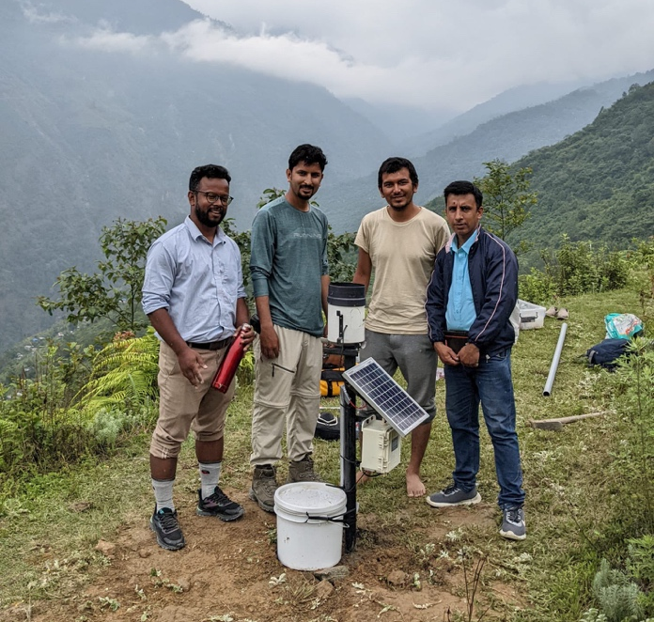
Members of the WP1 team installing hydro-met stations in Sindhupalchok
We were also joined in Sindhupalchok by Dr Katherine Arrell from Durham who has been working on the use of participatory 3D models as a dynamic communication and engagement tool. We conducted a pilot workshop in Kodari in Bhote Kosi to explore the potential uses of 3D models within Sajag-Nepal. Katherine worked closely with Sarmila at NSET to build the model, and with Sunil and Dipak in the field, and ran a workshop facilitated by Dipak and Mukta. The 3D model of the landslide affected area in Kodari was set up in the community meeting hall and a series of images and datasets were projected onto the model allowing residents to identify their houses and key landmarks, to share their knowledge of the hazard and risk environment, to see the outputs from the landslide mapping work and to explore and discuss the data with the team. We also used this as an opportunity to discuss the landslide monitoring, where the equipment would be installed and what it will hopefully be able to tell us about the area as a whole. We plan to use similar models in other locations as a way of bringing together knowledges and understandings of the landscape.

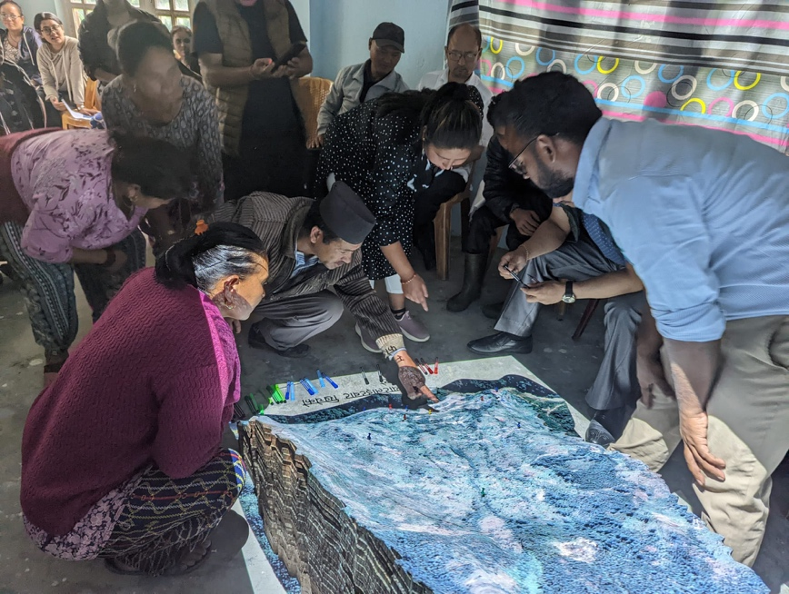
Dipak and Mukta using a 3D virtual model to share and explore knowledges of the hazard and risk environment in Kodari, Bhote Kosi
Nick and Katie also spent time with Anuradha and Sara in Dolakha, and Tek and Mukta in Kavre to learn more about the palikas and to finalise the selection of locations for the landslide monitoring work, ready for the installation during the next phase of fieldwork in August. In both Bhimeshwor and Temal we had some wonderful discussions with residents and each other about the landscape and what the slope monitoring may tell us. We helped with the rice planting in Bhimeshwor as part of the traditional labour exchange, and visited the land deity in Temal asking for support and guidance with the landslide monitoring. The installation of the slope monitoring equipment in Kavre begins on the 5th August so please follow the team on Twitter for regular updates.
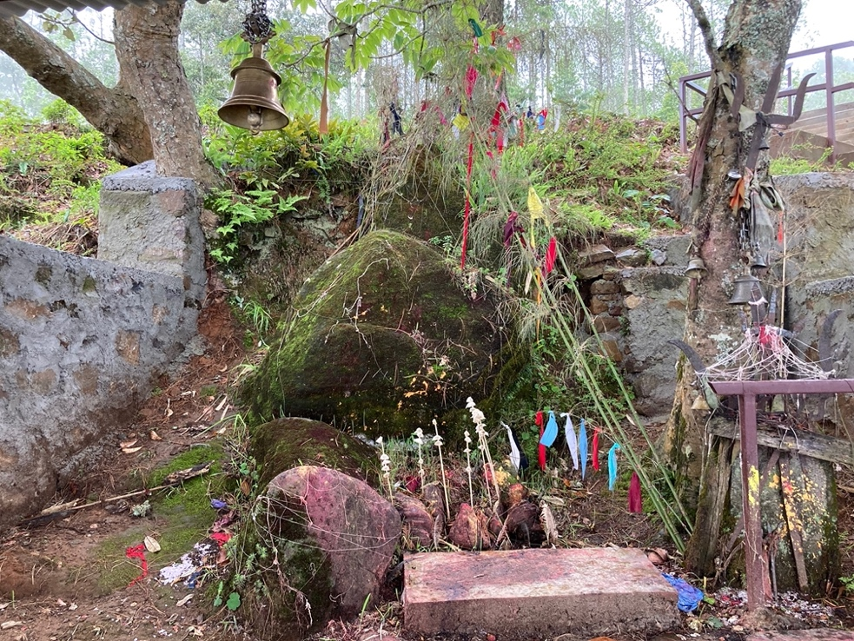
Visiting the shrine of the land deity in Temal

The Social Science Baha Team has also been working to set up a participatory photography project involving around 20 people across the case study palikas. Each participant has been given a camera phone and has been asked to take pictures of daily life during the monsoon, and to post these images with a brief description to a closed Facebook group set up and managed by Nyima. It is hoped that some of these images will feature in our photographic exhibitions alongside images and videos captured as part of the ethnographic fieldwork including Nyima’s film of Rupse Bhumi Puja in Dhana. The team has been sharing some of the stories emerging from their ethnographic fieldwork with colleagues from BBC Media Action with a view to informing their radio programming too. We look forward to taking these conversations forward with the wider project team.
In June, Amy began her fieldwork in Dadeldhura in the Far West of Nepal and Anudeep in Bhojpur in Eastern Nepal, two satellite case studies within Sajag-Nepal. Both Amy and Anudeep are focusing on local knowledges of the hazard and risk environment, lived experiences of earthquakes and landslides, and disaster governance. The case studies will add to the richness of the ethnographic work in the four core palikas in central and western Nepal.
Finally, Team members from BBC Media Action have been working on analysing the results of the Nepal-wide media survey that was carried out earlier this year. The survey collected data from nearly 6,000 respondents across all districts in Nepal, and included questions on hazard and risk perception, information sources, as well as media usage and trust. Sumitra KC presented some of the findings from the survey at the June team meeting. An important headline result for us is that radio is still a widespread and highly trusted source of information, especially for weather forecasts and monsoon preparedness. Facebook remains a commonly-used source as well, which is useful for understanding how representative the Facebook mobility data might be; but interestingly, trust in social media is extremely low. The survey also provides us with some excellent data on the hazards that respondents were concerned about, and what kind of information they sought in order to prepare for those hazards.

Work Package 2
In early April Sweata, Alex Dunant, Tom, and Alex Densmore organised a set of workshops in Kathmandu with the clusters that make up the Humanitarian Country Team, working closely with Prem and Bronwyn in the RCO. Representatives of all 11 clusters attended the workshops, and talked through the ways that they currently work up their parts of the earthquake and monsoon preparedness plans (ERPPs), as well as the sources of data that they rely upon. We used a timeline exercise to think through the types of information that could be valuable to the clusters, as well as the times that this information would be needed – for example, three months or one month before the onset of the monsoon. A full report on the workshops is available at https://www.sajag-nepal.org/2022/04/15/support-for-emergency-response-planning-by-the-un-humanitarian-clusters/.
Team members then met up in Durham in late June to discuss the outcome of the workshop data gathering, and how it could inform our monsoon visualisation and risk modelling work. A follow-up set of workshops with the clusters is planned for mid-September.
Alex Dunant has been working on constructing a risk modelling framework that is efficient enough to operate at a national scale and be run quickly and repeatedly, which will allow us to consider many different earthquake or monsoon scenarios. This model makes use of a novel way of linking elements at risk – such as buildings or any other infrastructure – with the spatial distribution of hazards. Initial tests of the model on the 2015 earthquake are promising, and show that we can generate building-level estimates of risk from multiple co-occurring hazards, such as earthquake shaking and landsliding.
Tom and Alex Densmore gave briefings on the Sajag-Nepal project, and the underlying principles that are guiding the project, to different UN groups. Tom spoke to the heads of RCOs across the Asia-Pacific region, while Alex briefed UN staff in Nepal who are working on the UN Sustainable Development Cooperation Framework (which replaces the old Development Assistance Framework as the overall guide to development activities in the country).

Work Package 3
Sihan has been splitting her time between two related sets of tasks. She has been running Hydro-JULES simulations to generate national-scale soil moisture and runoff estimates, for comparison to well-dated landslide events in the Bipad database. This should allow us to refine our estimates of landslide occurrence, especially when combined with field estimates of soil moisture from our nascent monitoring network. Sihan has also been analysing seasonal and shorter-term forecasts and precipitation patterns in order to understand the spatial and temporal variation of rainfall across Nepal, the differences between different monsoon years, and the most effective way of linking those differences to impacts on the ground. This has led to some novel ways of visualising monsoon forecasts as well as identifying rainfall patterns that are more or less likely to lead to landsliding; these will be shared with the team later this summer.
In parallel with this, Sarmila has been collating information on the most damaging landslides to have occurred over the last few monsoon seasons. A great opportunity has arisen to link this dataset with reports of landslide impacts that were collected by the Department of Hydrology and Meteorology during the 2021 monsoon season as part of the ARRCC project’s impact-based forecasting pilot. Sarmila attended the launch of the 2022 impact-based forecasting effort in June, and now is working through the impact reports from 2021.

Research ethics
The Sajag-Nepal project has undergone ethical review at Durham University and we have received approval to begin the research. A copy of the documentation (including a project risk assessment) is available via OneDrive for the team to access. As previously discussed, this is very much a live document and work package leads will be responsible for updating and resubmitting amendments as required, and as the research evolves. A big thank you to everyone who fed into this process. Any questions, please contact Katie: katie.oven@northumbria.ac.uk

Social media
We are pleased to announce that the Sajag-Nepal project website is now live www.sajag-nepal.org We welcome all members of the team to contribute to the content as much as possible. If you would like direct access to the editing pages of the website, or you have recommendations to make, please contact Rachel in the first instance.
Sajag-Nepal is active on Twitter (@SajagNepal) We also feature on the recently relaunched Radix website (Radix: Radical Interpretations of Disasters), as an example of a project with its own ethical guidelines which build on the principles of the Disaster Studies Manifesto: Power, Prestige and Forgotten Values.
Alex Dunant has started a project Slack platform and several team members are active on Slack – if you are interested in exploring this as a way to communicate across the project, please contact Alex directly (alexandre.dunant@dur.ac.uk).
We are moving from Google Drive to OneDrive for general project materials and information. If you experience access issues accessing documents, or have any other queries or concerns, please contact Rachel.
Project communication guidelines have been developed with input from the WP leads, with guidance for good practice and things to consider when communicating about the project. This is available on the project OneDrive and Google Drive. We will continue to update and refine this, so please send any suggestions to Rachel.

Recent publications
If you have recently published a paper or other output that is relevant to Sajag-Nepal, please send the details to Rachel and we will list them here for the team to see. Please include the DOI and a link to any open-access version, if possible. This information will also be included on the publications section of the website and will be saved on file for future reporting purposes.

