Overview
Welcome to the latest in our series of quarterly newsletters for the Sajag-Nepal project. The purpose of these newsletters is to summarise the breadth and depth of research across the project, highlight outcomes and outputs that we want to share more widely, and draw attention to upcoming activities or milestones.
Work on the project is really ramping up across all areas of what we are doing, and the sections below give a detailed summary of what has been happening in specific parts of the project over the last few months. Importantly, though, we are also increasingly working and talking across work packages. The shared field work in the case-study palikas in September was an excellent example of this. I’m very proud of how the whole team has pulled together in order to install the slope stability monitoring equipment, and the tremendous amount of work that has been done to ensure that these sites are chosen to address community concerns while also yielding new scientific understanding. Installing the acoustic emissions sensors and getting the data loggers running was a milestone, but it was just the most recent part of a long effort and would have been of very limited use without all of the discussion, debate, and organisational effort up to that point. We don’t know what we will find – that’s the point of research – but I’m pretty confident that we have done all we can to put those results in context, to not over-promise, and to be clear and honest about the value and limits of that new scientific information.
There’s also been substantial progress on the themes within work package 1, and the RAs at the Social Science Baha have now compiled a really impressive set of interview notes, reflections, and observations. It’s clear that knowledge of, and small-scale adaptation to, the mountain hazard chain are both widespread and varied across the areas that we are working. A challenge now for us as a project is to bring that often sophisticated view of the mountain hazard chain to places where it isn’t often recognised or heard – such as large-scale contingency plans. Along those lines, the team held a very illuminating set of follow-up workshops with the Humanitarian Cluster Team, and are now in a great position to focus our work on risk modelling to the needs of the clusters in their national-scale planning. We need to ask similar questions of government, at different levels, and to bring those risk models into conversations in the palikas as well to see just how useful they could be.
I’m delighted to welcome Max van Wyck de Vries to the project. Max has taken up the PDRA position at Oxford working with Simon. Max brings an exceptionally broad Earth sciences perspective to the project, and he has already started working with Simon, Nick, Alex, and the rest of the team to figure out where he can best contribute. Sihan has now started an academic position at Sheffield and Mark has started a position at Newcastle, but we are very fortunate that both have agreed to stay closely involved in Sajag-Nepal.
Looking ahead, a number of team members will be involved in field work before the end of the year on governance at both palika and district levels. We are also planning for visits to the UK for the Britain Nepal Academic Council meeting next April, as well as the next round of workshops with the Humanitarian Country Team around the same time. And remember that Sajag-Nepal will be represented at the Asia Pacific Regional Humanitarian Week and the ADRRN general meeting in December – more on this as it takes shape.
Alex Densmore

SPOTLIGHT ON RESEARCH
As part of our ‘spotlight on research’ section, Sweata Sijapati, from NSET, took part in our quiz, please read on to find out more!

Q1. Tell us a little bit about you and your background
I am an Environmental Engineer and researcher involved in disaster initiatives and its advocacy, humanitarian aid and coordination, urban climate studies and its effect on local climate. As a part of my PhD research, I focused on the ground-based measurement of the solar radiation to understand the temporal and spatial distribution of the solar radiation and the sky condition which is beneficial for understanding the local climate pattern such as torrential rainfall and impact of urbanization. Prior to joining Sajag-Nepal, I worked for the post-earthquake recovery and reconstruction following the 2015-Gorkha earthquake. I specifically worked to develop recovery strategy that identifies needs, gaps, vulnerabilities, and resources in order to ensure an overall response that is coherent, effective through strategic direction, technical advice, and information management. My professional experience has made me capable of understanding the context of DRRM in Nepal and capacitated me in building relationship with professional working in the same field as well as enhance my coordination skills with the various tiers of Government, partner organizations, and relevant stakeholders.
Q2. What drew you into your research area?
Being born in a nation widely known for Himalayas, hundreds of rivers and rivulets but to the irony the nation was facing hours of power-cuts every day, people had to queue up for hours to collect drinking water, urban flooding became common, and people lived in fear of earthquake and landslides. Experiencing such cases, I had a great desire to understand the cause and effect of such events and gain knowledge on disaster risk affecting thousands of families in Nepal including mine, which led me to undertake disaster studies as my major in the university. During these periods, I became well acquainted with the disaster mitigation and its awareness, atmospheric studies notably related to urban climate and its impact. It also created the avenues to explore the technologies both financially and technologically viable for developing countries like Nepal. As a researcher, I frequently realized that even though Nepal faces multiple disasters every year, we had a poor system to manage information and database of such events. The hassle to find the data, right person to approach for the authentic information, moving from one organization to another was discouraging to some extent, but this at same time motivated me as an individual to move forward as a researcher and inspired me to develop my career as professional in DRRM and work in strengthening the capacity of government and communities in disaster risk management and risk transfer. As an academic and professional in field of disaster, I believe receiving a formal education is one of the biggest assets but using that to make community resilient to disaster is the biggest challenge.
Q3. What part of the project are you looking forward to the most?
Working in the post-earthquake reconstruction for over 4 years, I found so much scope in disaster reduction and mitigation work in Nepal, but very least understood and implemented. Thus, being a part of Sajag- Nepal, it will be interesting to see how the research outcome will have a greater impact in supporting the governmental/organizational and societal changes required to build resilience amidst wider growing uncertainties. With the inclusion of natural and social science to accelerate and scale-up the understanding of multi-hazard risk in Nepal, I look forward to seeing changes in traditional approach of disaster planning being shifted to more scientific evidence based.
I also look forward to working with the multidisciplinary team with diverse expertise and enhance my knowledge in wider areas within DRR. I am excited in learning more on partnership development to create a conducive and trustworthy environment among various stakeholders and experts in this field. Being involved in this position and realizing my efforts and knowledge can bring changes in understanding the disaster scenario in Nepal is undoubtedly the biggest driving force for me.
Q4. What do you hope to have achieved by the end of the project?
At the end of the project, I am convinced on having a better understanding of multi-hazard risk in Nepal and move a step ahead as an interdisciplinary researcher. I anticipate building relation among different stakeholder from Government, partner organization to individuals working in the DRR field. Other exciting aspect for me would be able to publish research articles for wider readers. Last but not the least, it would be ideal to see disaster plan of Nepal prepared with proper scientific evidence and focused more on preparedness rather than just relief and response.
Q5. Tell us an interesting/surprising fact about yourself
I love exploring new places, meeting new people as I believe every place and person has a story to share.

Updates from the Work Packages
Work Package 1
Since June, members of the Work Package 1 Team have been pushing ahead with the installation of slope monitoring equipment and with ethnographic research on local knowledge, disaster governance, and exposure and vulnerability in the monsoon. As monsoon 2022 ends, we are happy to share that we have slope monitoring stations logging and transmitting data from five palikas, with two in Bhote Koshi, one in Annapurna Rural Municipalities and one in Temal. We are currently working on the installations of the final instruments in Temal and Bhimeshwor. These remaining tasks will be completed in the next few weeks after the festival season winds down in late October.
Getting the stations ready by the end of the monsoon was a team-wide effort. The Research Associates at Social Science Baha and Tribhuvan University worked tirelessly with community members to finalize site selection and provide support for the drilling team in advance of the UK team’s arrival in September. A big thank you to Tek, Anuradha, Nyima, and Dipak from Social Science Baha, Nawaraj and Subash from Tribhuvan University, as well as Ramesh from Durham and Gopi from NSET for their technical support. We are also extremely grateful for the support communities in the palikas gave to the installation work, which ranged from helping finalize sites and securing permission to establish monitoring stations on private land, to carrying very heavy equipment over difficult terrain and sourcing water for the drilling machine. The team was also joined by Prof. Megh Dhital and Alex Densmore who visited all the slope monitoring sites with the assistance of our brilliant driver Babu. They ensured that the stations were in tip-top shape and ready to deliver information about rainfall, soil moisture, and slope movement for the next two years of the project.

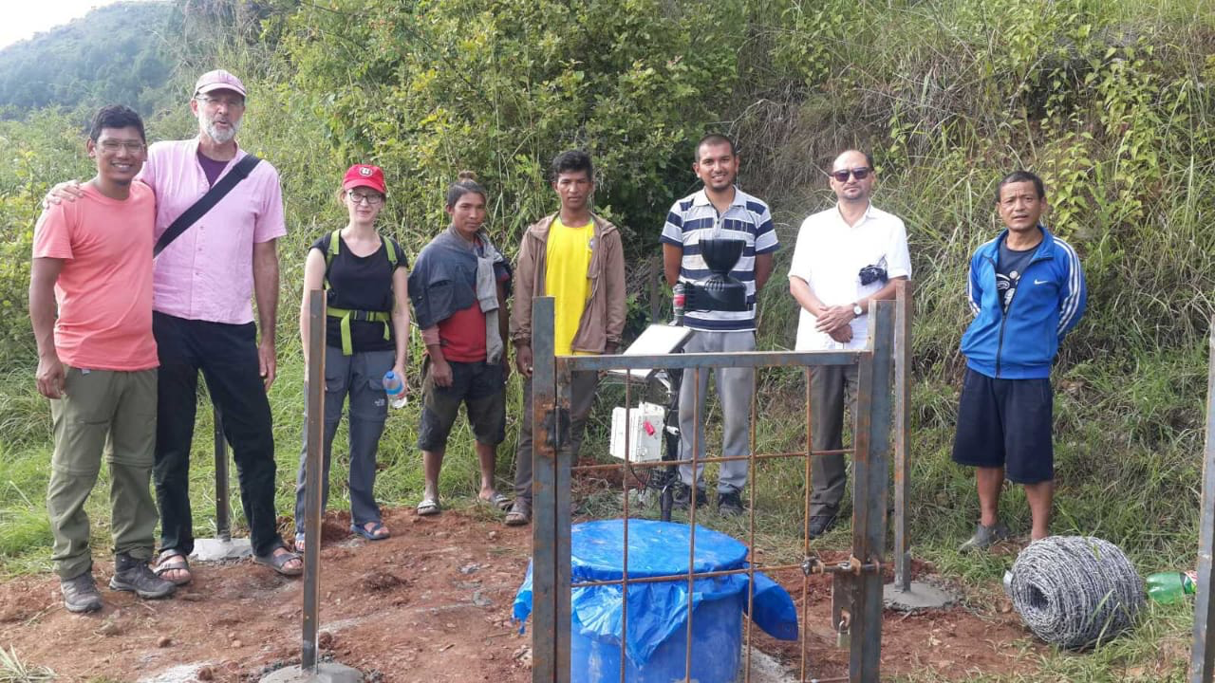
Members of the Sajag-Nepal Team at one of the slope monitoring sites in Temal, Kavre District

Over the course of our visits to the slope monitoring sites, Gopi, Ramesh, Alex, and Megh had many opportunities to interact with local community members. In an interaction with community members in Bhimeshwor’s Boshimpa village, Anuradha Puri helpfully introduced our physical geography colleagues as “Earth Doctors” and encouraged community members to ask them about their ability to diagnose changes observed in the landscape. The common questions asked to the Earth Doctors in Boshimpa and other communities included the science behind the slope monitoring equipment and how changes community members were observing in their immediate environments connected to larger processes in the landscape that could portend landslides or rockfalls. Megh, Ramesh, Gopi and Alex helped the RAs translate core ideas about the research and its possibilities to communities. They were also clear about how the research was not developing an early warning system for landslides, although the data may be useful for designing early warning systems for landslides in the future. We are currently planning workshops with communities in the slope monitoring sites to share and interpret data together after the monsoon.

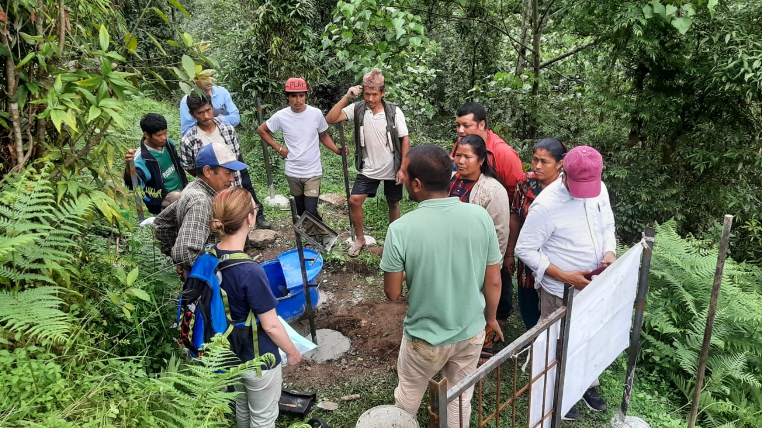
Ramesh explaining how the slope monitoring equipment works with community members in Bhimeshwor.

In parallel to the work at the slope monitoring stations, Jonathan Rigg, Amy Johnson, and Mukta Tamang carried out ethnographic interviews about exposure and vulnerability in Annapurna and Temal Rural Municipalities. This was Jonathan’s first trip to Nepal with the Sajag-Nepal team. We had memorable experiences walking across landslides in Annapurna and Temal, which led to insightful conversations with community members about day-to-day negotiations of hazards and monsoon preparedness. Thank you to Mukta, Tek, and Nyima for making our time together so productive and enjoyable.
We were also fortunate to have Prem Awasthi from the UN RCO join us for two days of fieldwork in Bhimeshwor Municipality. Prem engaged in lots of conversations with community members about the humanitarian aspect of disaster planning, preparedness, and response. He was also a keen videographer and social media documentarian for the team. His enthusiasm for the research was catching and kept us motivated during the long days, rain, and leeches.
After completing work with the RAs and the slope monitoring teams in the four main case study palikas, Amy moved to Sudurpaschim Province’s Dadeldhura District to carry out a second round of research in Parashuram Municipality. Her time this research trip was focused on learning more about local knowledges of landscape change and the social dynamics of landslides, in particular women’s perspectives on geology. She had the opportunity to speak to many residents living along the rivers and in the Siwalik hills about their migration into Parashuram and changes they have observed in the environment over their lifetimes. Amy presented her initial findings in a seminar at the University of Edinburgh’s Centre for South Asian Studies titled ‘The social lives of landslides: Moving land and people in a Himalayan valley’. She will be continuing to work on themes of local geological knowledge and disaster governance in fieldwork planned for early 2023.
Jeevan Baniya, Sweata Sijapati, and Anuradha have also begun a series of interviews about disaster governance at different tiers of government. Anuradha and Sweata travelled to Hetauda to interview members of the Humanitarian Clusters about their experiences designing and implementing disaster policies for Bagmati Province. Jeevan carried out interviews with district-level representatives in Beni to analyse coordination and implementation of disaster plans and policies for Myagdi district. Jeevan, Sweata, and Anuradha have planned further research on province and district level disaster governance, with fieldwork in Dolakha scheduled for October-November.
Before international team members returned to the UK at the end of September, BBC Media Action and Alex Densmore led a meeting at NSET to discuss research, messaging, and professionalization. BBC Media Action colleagues organized activities in the morning to help us think about how insights about local disaster preparedness we are learning in the ethnographic fieldwork can be communicated at different scales regionally and nationally. They also gave helpful suggestions about how to interact with journalists, a skill we are beginning to develop as Sajag’s work in the palikas becomes more widely known and reported. We ended the day with a discussion on life after Sajag, with some preliminary conversations about transitioning into PhD programs or leadership roles in research and development organizations. We plan to continue these conversations with the RAs and early career researchers in future professionalization meetings planned after Tihar.
Finally, Amy, Katie, Nick, Jonathan, Mark and Marcus organised a conference session at this year’s Royal Geographical Society conference which was held in Newcastle. The session titled ‘Plural Environments and the Interdisciplinary Study of Disaster’ was co-sponsored by the Social and Cultural Geography Research Group and the British Society for Geomorphology, and brought together a range of speakers across two sessions covering a range of hazards and geographical contexts. The session papers and associated discussions have helped us to further define our conceptual framework and to consider how we engage with mountain hazards and risks as an interdisciplinary team, ideas that we will be reflecting on further in a roundtable discussion as part of this year’s Himalayan Studies Conference in Toronto.

Work Packages 2 and 3
Over the past few months, the team has been focussing on the development of the earthquake and monsoon scenario models, preparing for Round 2 of our workshops with the HCT in Nepal in September, and talking with provincial leaders and clusters about their knowledge and understanding of the Emergency Response and Preparedness Plans (ERPPs) that are coordinated by the UN RCO. The overall aim is to gain a better understanding of both the type of data that different clusters require to prepare their ERPPs as well as the spatial and temporal resolution of that data. As part of this, we are attempting to understand what new capacity this data would give each cluster and how this would help improve their current earthquake and monsoon ERPPs. Sweata, Alex Du, and Sihan have been working closely together over the last few months to develop these models and to prepare the HCT workshops which were held in September.
As part of the scenario modelling, Alex Du has been working closely with Sihan to tweak his earthquake models to be able to effectively model landslides and their impacts from the monsoon. In particular, they’ve been working to produce initial draft relative risk models for use in our September workshops with the HCT to help with the discussions. This has focussed on developing the capacity to integrate the weather / climate data format into the multi-hazard model, and Alex has now successfully accomplished this! The output is an estimate of relative risk of impact arising from a particular pattern of rainfall – e.g., a seasonal forecast, or 72 hr forecast – at the building scale across all of Nepal.
At the same time, Alex has also been working on the building vulnerability curves to be used in the earthquake multi-hazard modelling. This has involved compiling many of the different available vulnerability curves and comparing their performance against the impact observed during the Gorkha earthquake. Tom and Alex met with Surya, Ramesh, and Gopi at NSET during our visit in September to discuss some of the issues arising from this work. Alex has now successfully completed this work and is currently writing this up into a paper (tentative title: “Impact from connected multi-hazard using hypergraphs : case study from the 2005 Gorkha earthquake in Nepal”).
As well as all this, on 31 July there was a M_{w} 5.1 earthquake in Bhojpur. Nick received a request from Ranjan Dhungel at HRRP for some initial modelling of the potential housing damage this event might have caused. Alex has been working on tuning his multi-hazard model to this event, and was able to show that damage is likely to be limited to the epicentral area, although in the high impact case up to 1,500 buildings may have been severely damaged in Bhojpur and Khotang combined.
Sweata has been working on the data gathered from first round of our HCT workshops back in April. This focussed on using a timeline exercise to think through the types of data that could be used and the different decisions that each cluster currently undertakes at different stages pre- and post-disaster (monsoon and earthquake). At the same time, she’s been looking into the 2022 monsoon predictions published by DHM, and how NDRRMA and the HCT use these predictions (or not) to help inform their monsoon ERPPs in May.
In August, Sweata began a series of what we hope will be ongoing conversations with the provincial-level clusters to understand their level of knowledge and use of the national ERPPs. Interestingly, Sweata found that whilst knowledge of the ERPPs is variable, in the main very few of the Provincial-level clusters actually use the national ERPPs or prepare their own provincial ERPPs in advance of the monsoon or for earthquakes. This has real implications for how we embed our national-level work with the clusters at provincial and more local levels. We plan to continue discussing the ERPPs and current and past scenario ensembles work with the provincial clusters to see how we can connect our national and provincial scale work.
In September, Sweata, Alex Du, Sihan, Tom, and Alex De undertook the second round of workshops with the 11 individual clusters in UN House. While the first round in April had sought to understand the current planning and timelines used by the different clusters, this round focussed on answering two questions:
- What format and type of risk information would be most useful to your cluster for preparing your ERPPs? How would you actually use this information to help plan? ​
- What new capacity would this data give you? How might your ERPPs change as a result?
The workshops focussed on the spatial and temporal resolution of the relative risk estimates that Alex Du and Sihan can produce, including their uncertainties, asking the clusters which of these was most important to them and why. We started with an open round table discussion which highlighted some interesting components. For instance, we noted that the higher resolution models were likely to be much more uncertain than the lower resolution models. One cluster member noted that was fine and the model would be useful even if we could only get to 95% accuracy. This pointed up a real disparity between what the clusters think of as accurate and inaccurate versus what we as modellers think of as accurate and inaccurate, and poses some interesting questions around how we communicate our models.
Another interesting point around the high resolution models was brought up by multiple clusters, who noted that even if the building-level impact results were wrong, there were likely to be impacts in nearby buildings or villages so the model was still useful.
After the open discussion we moved into a series of exercises where we asked the cluster members to vote on which model outputs they preferred across three different temporal and three different spatial scales. Each member had 6 votes they could use and they could vote for 3 different temporal and spatial scales. After an initial voting round, we then asked each member to expand on why they voted for that particular combination of spatial and temporal outputs, noting in particular what new capacity this data would give them. They were also asked about any key infrastructure that would be useful to include in the modelling – for example, the locations of bridges, or schools, or health posts.
We are still processing the results, but there was a clear preference for increasing spatial resolution with decreasing temporal resolution. Participants generally wanted model outputs at all temporal resolutions (seasonal, fortnight, and 72 hrs) but were happy to have lower spatial resolution (provincial) for the seasonal forecasts, and to higher spatial resolution (building-scale) for the 72 hr forecasts. As a result of the workshops, we received additional queries from WFP and IOM to explore the use of the risk model for their non-ERPP work.

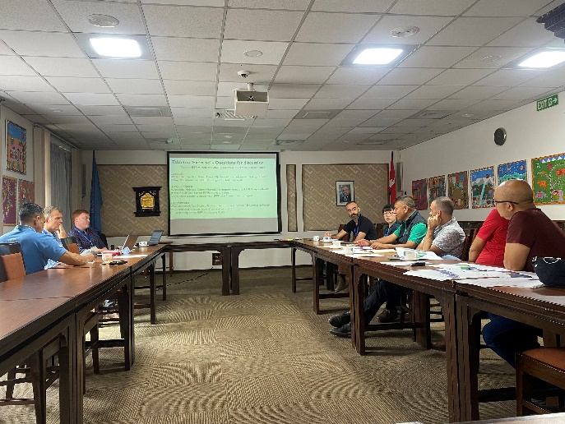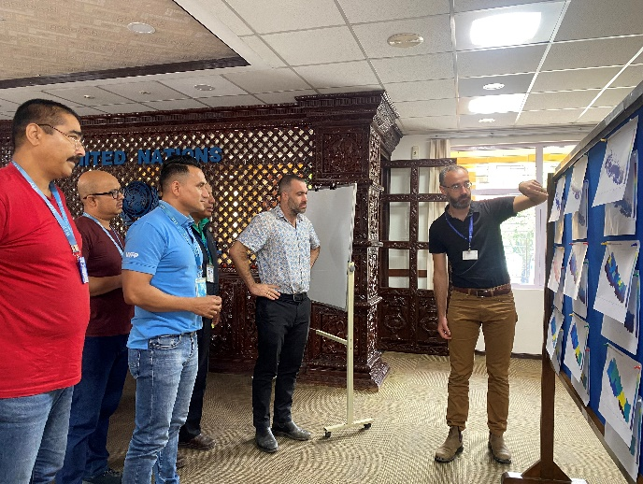
Left: Round table discussion with the clusters in UN House. Right: Alex Du introduces the modelling outputs and invites participants to vote on which they most prefer.
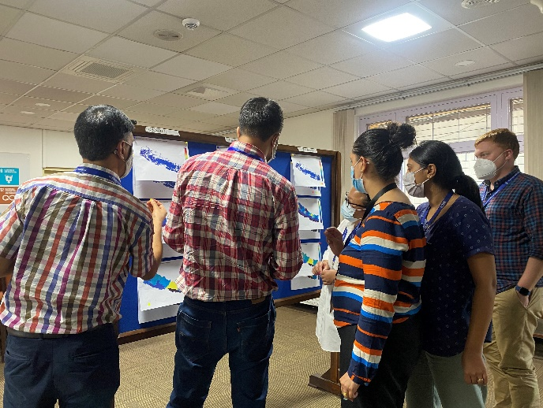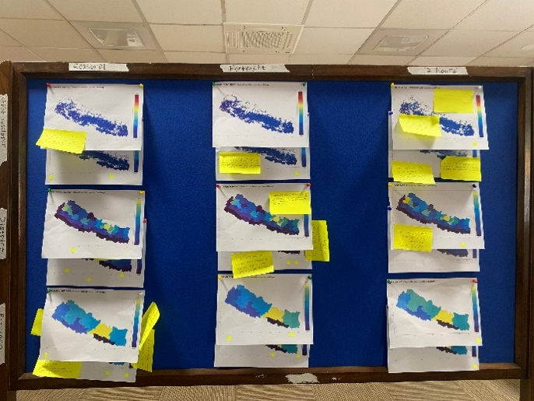
Left: Workshop participants discuss and vote on the different model outputs. Right: example of a completed voting exercise with dots showing voting preferences and sticky notes containing details of the new capacity this data could give the cluster.

Initial summary of voting preferences from all 11 clusters. The left-hand side shows the timing of the forecast (seasonal, 14 day, or 72 hours), while the right-hand side shows the level of aggregation of relative risk (by building, averaged by district, and averaged by province). Taller bars show a greater number of votes, with the seasonal-provincial model being the most preferred model across all clusters.

A key next step is going to be taking this risk modelling approach to the palika level and exploring whether it is relevant
Finally, during our time in Nepal in September, Alex Du, Sweata, Sihan, and Tom also met with BBC Media Action to discuss our upcoming work on the Facebook Data for Good Mobility data and BBC Media Action’s ongoing surveys on internet and app usage around Nepal. We hope to continue working together to see how our respective projects can benefit one another over the coming years.

Work Package 4
We’ve temporarily paused work on WP4, which builds on the work from WP1-3. Elements of this work package will start to move forward later this year, in collaboration with the NDRRMA and IFRC.

Research ethics
The Sajag-Nepal project has undergone ethical review at Durham University and we have received approval to begin the research. A copy of the documentation (including a project risk assessment) is available via OneDrive for the team to access. As previously discussed, this is very much a live document and work package leads will be responsible for updating and resubmitting amendments as required, and as the research evolves. A big thank you to everyone who fed into this process. Any questions, please contact Katie: katie.oven@northumbria.ac.uk

Social media
Sajag-Nepal is active on Twitter (@SajagNepal) and our project website (www.sajag-nepal.org) is fully open for blog posts and reports. If you would like to tweet or post to the website, please contact Rachel for login details. We also feature on the recently relaunched Radix website (Radix: Radical Interpretations of Disasters), as an example of a project with its own ethical guidelines which build on the principles of the Disaster Studies Manifesto: Power, Prestige and Forgotten Values.
Alex Dunant has started a project Slack platform and several team members are active on Slack – if you are interested in exploring this as a way to communicate across the project, please contact Alex directly (alexandre.dunant@dur.ac.uk).
We are trialling a move from Google Drive to OneDrive for general project materials and information. We have started this with materials for our monthly team meetings, and if there are no access issues then we will extend this to other documents as well. Please contact Rachel if you have any questions or concerns.
Project communication guidelines have been developed with input from the WP leads, with guidance for good practice and things to consider when communicating about the project. This is available on the project OneDrive and Google Drive. We will continue to update and refine this, so please send any suggestions to Rachel.

Recent publications
If you have recently published a paper or other output that is relevant to Sajag-Nepal, please send the details to Rachel and we will list them here for the team to see. Please include the DOI and a link to any open-access version, if possible.

