Overview
Welcome to the latest in our series of quarterly newsletters for the Sajag-Nepal project. The purpose of these newsletters is to summarise the breadth and depth of research across the project, highlight outcomes and outputs that we want to share more widely, and draw attention to upcoming activities or milestones.
The last few months have been dominated by preparations for the 2023 monsoon season. The release of the regional-scale seasonal monsoon forecast from SASCOF, and then the follow-up Nepal-specific forecast from DHM, has been a useful focal point for the project. Project team members fed into a summary briefing for NDRRMA on what could be expected to occur in the upcoming monsoon, as well as a summary of the existing landslide susceptibility model using the newly-released 2021 census data. Some of this information has now been incorporated into the NDRRMA’s monsoon preparedness plan. Even though the seasonal forecast is necessarily vague, and doesn’t capture the details of what will actually occur during the monsoon, it is a good opportunity for us to think about what we can say based on the research to date, and what we would like to prioritise before next year.
The monitoring stations are continuing to collect weather, soil moisture, and acoustic emissions data, and we should be able to compile this information over the full monsoon cycle this year. There has been quite a bit of work over the last few weeks on producing materials that the RAs can share with the communities about the monitoring stations, to help answer questions and build awareness of what we are doing. Importantly, members of the team met with the government of Bhimeshwor palika, including the mayor, deputy mayor, ward chairs, and DRR focal person, to explain the monitoring work and the wider Sajag-Nepal project. This was productive and positive overall, and the palika expressed their desire both for regular reporting and also for the monitoring data to be shared with the MEOC information board in the palika.
In May, Katherine, Anuradha, Dipak, and Sarmila carried out joint field work to explore themes around mobility and exposure. This involved a novel use of participatory mapping to document knowledge of the landscape and patterns of movement (and how they varied with time and between different groups of people). This information will feed into national-scale dynamic exposure datasets, based in part on ongoing analysis of the Facebook mobility data. They also worked on generating different ‘maps of knowledge’ around themes like rock type, soils, rainfall, and landslide warning signs, as a new way of collating and representing local knowledge.
Gopi represented the project in a regional meeting on anticipatory action in late May, and this was followed by a big presence from the project at the 7th Asia-Pacific Dialogue Platform on Anticipatory Humanitarian Action on 13-15 June in Kathmandu. Prem, Tek, and Gopi were there on behalf of the project, and Tek has provided a detailed summary of the meeting below. Many thanks to all of them for representing the project and especially for ensuring that our perspectives on local knowledge were heard clearly.
You will probably be aware that Amy is joining Georgia College as an assistant professor of anthropology. This is fantastic news for Amy and they will be very lucky to have her insight, expertise, and enthusiasm as she starts on the next chapter of her academic career. Happily for us, Amy is keen to stay involved with Sajag-Nepal as much as her schedule allows, and we’ll be working with her to find ways to make that happen. It’s also worth mentioning that Rachel has shifted her work schedule on Sajag-Nepal slightly, in order to take up a permanent part-time job elsewhere at Durham University. Rachel will be working on Sajag-Nepal on Monday, Tuesday, and Thursday mornings (UK time) and all day on Fridays.
Finally, as I write this we are getting ready to welcome Ram, Dammar, and Sarmila to the UK for a two-week visit. Erin has put together a full schedule of writing workshops and discussion sessions, with time set aside both for specific outputs from their work as well as broader conversations with the wider project team. Many thanks in particular to Rachel for all of her efforts to organise the visit and make sure that it runs smoothly.
Alex Densmore

SPOTLIGHT ON RESEARCH
As part of our ‘spotlight on research’ section, Erin Harvey, from Durham University took part in our quiz, please read on to find out more!
Q1. Tell us a little bit about you and your background
I am a geomorphologist and physical geographer with an interest in mass movements, in particular the hazards they pose and how they shape the landscape. I recently completed my PhD at Cardiff University in the UK, which explored controls on the runout and magnitude of extremely large debris flows following the 2008 Wenchuan earthquake. In my research, I enjoy using a combination of methods, including fieldwork, lab work, remote sensing, and modelling and I’m keen to continue using a wide range of methods on the Sajag-Nepal project.
Q2. What drew you into your research area?
My interest in natural hazards stems from studying Geography at school and learning that we could not predict earthquakes. Following the events in the aftermath of the 2009 L’Aquila earthquake, I was keen to learn more about the hazards posed by earthquakes. I moved to Durham in 2014 to complete my undergraduate degree in Geography, choosing to specialise in hillslope processes. During this time, I got the opportunity to travel to different mountain regions and observe how landslides and debris flows heavily impact local communities and landscapes. During my PhD, trips to the villages and towns impacted by the 2008 Wenchuan earthquake reinforced the importance of using a process-based approach to better understand the impact of landslides and debris flows. Even 10 years following the earthquake, these communities are prone to extremely large landslides and debris flows. The persistent devastation caused by landslides in Wenchuan motivated me to continue researching landslides as a dynamic process and hazard.
Q3. What part of the project are you looking forward to the most?
I am really excited to be joining a large international group of collaborators on the Sajag-Nepal project. I feel very fortunate to be able to acquire knowledge and technical skills from such an interdisciplinary team. I’m excited to visit Nepal (my trip in March was my first time in Nepal) and witness the incredible mountain landscapes and learn more about Nepali culture. I am also looking forward to working with the team to disseminate our findings directly to local communities, NGOs and government.
Q4. What do you hope to have achieved by the end of the project?
During my time on the project, I will continue Mark’s work developing a national, automated landslide inventory for Nepal. I aim to use this inventory to develop our understanding of landslides spatially across Nepal and explore how the processes and types of landslides evolve through time. I hope that these outputs can be used to build on our current landslide susceptibility models and the monsoon multi-hazard model. Technically, I aim to build on my remote sensing skills and ability to manage large datasets – there are a lot of landslides to map! I am also eager to develop my understanding of interdisciplinary research and am looking forward to being a part of an interdisciplinary team working together to mitigate risk and improve disaster resilience in Nepal.
Q5. Tell us an interesting/surprising fact about yourself
Despite finding most things very spicy, I spent two months in Sichuan Province, China, which is home to the Sichuan pepper. My spice tolerance has definitely improved since!

Updates from the Work Packages
Work Package 1
Work package 1 has been involved in several research activities since returning from Durham to Kathmandu at the end of April. During our Durham meeting we discussed the importance of being present in our field sites to observe and participate in activities and events related to our project research. Our immediate priority after researchers from the Social Science Baha team arrived in Kathmandu was to prepare for a series of targeted fieldwork trips to coincide with the start of monsoon. This fieldwork was organized around key themes of local knowledge, disaster governance, and mobility and exposure, taking advantage of budget planning activities and rituals scheduled to begin in late May and June in different palikas.
In mid-May, Katherine Arrell travelled with Dipak Basnet, Anuradha Puri, and Sarmila Paudyal to carry out participatory mapping in Bhotekoshi. The participatory mapping work will inform a new exposure data set that represents movement of people on the Bhotekoshi landscape. As part of this exercise, Katherine taught Dipak, Anuradha and Sarmila participatory mapping skills that can be transferred to work in other palikas in later fieldwork. We are excited to see how our newer spatial study of exposure and vulnerability can map onto local knowledges of hazard and disaster risk navigated by communities in their surrounding landscapes.
At the end of May, team members Anuradha Puri, Gopi Basyal, and Ganesh Jimee went to Bhimeshwor Municipality to present about Sajag Nepal's ongoing and planned activities. The meeting was an opportunity to formally introduce the Sajag Nepal project to the Municipality. In the meeting, Gopi also gave a presentation about the slope monitoring equipment to the members of Municipal Level Disaster Management Committee.
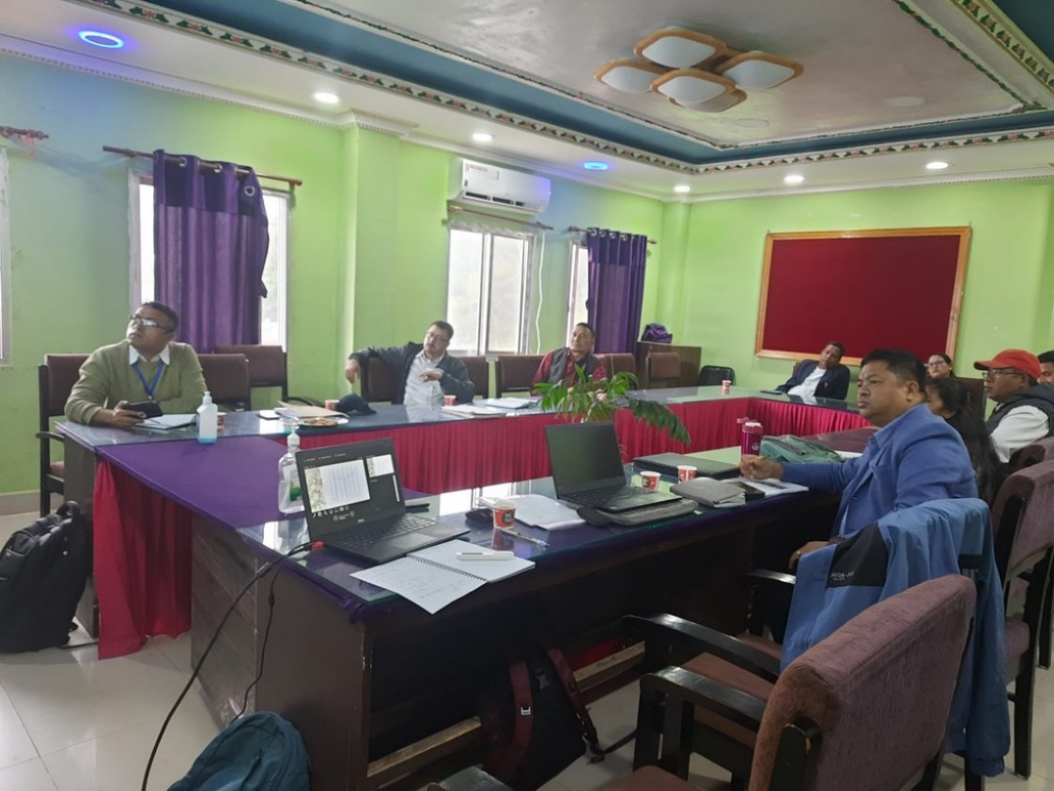
In early June, Nyima Dorjee Bhotia and Dipak Basnet travelled together to Annapurna Municipality to follow the budget planning process and to document how disaster preparedness projects and policies become part of conversations about budget priorities at the local level. They also spent time with community members preparing for the annual bhume puja rituals as a way to better understand local knowledges and practices that safeguard communities from harm and hazards. During this time, Nyima and Dipak also coordinated with NSET colleagues to conduct drone surveys of the slope monitoring installation sites and with BBC Media Action colleagues preparing to produce a film about disaster knowledge in Annapurna.
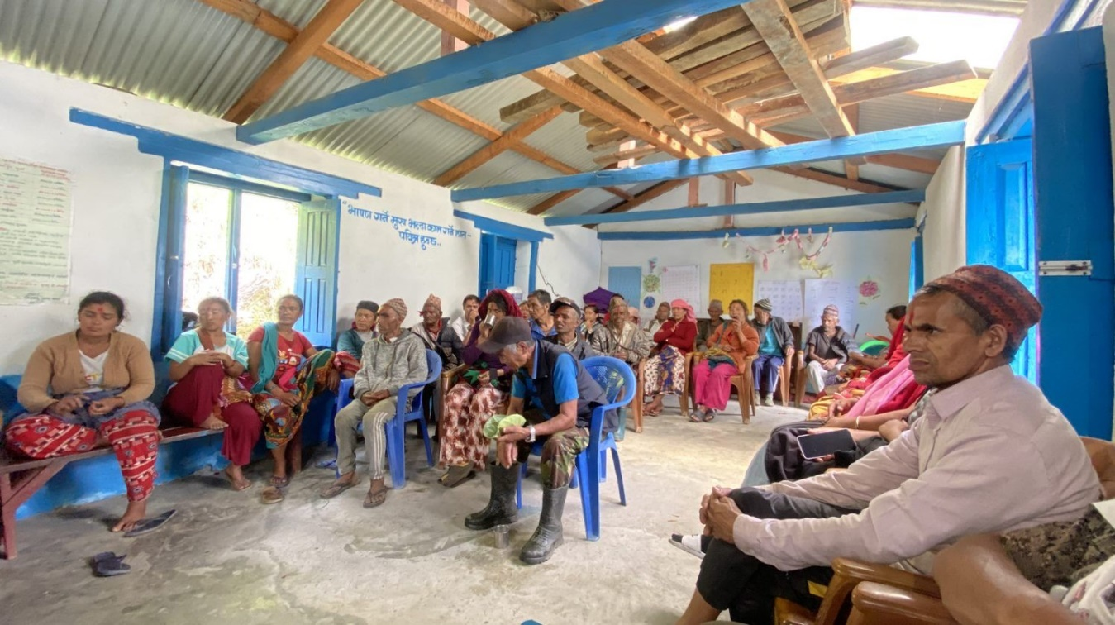
During the time of fieldwork in Annapurna, Anuradha Puri and Jeevan Baniya travelled to Bhimeshwor in Dolakha district to observe budget planning in the municipality and wards. Anuradha also coordinated with NSET colleagues and municipality government to conduct drone surveys of slope monitoring installation sites in Bhimeshwor. Dipak joined Anuradha in Temal Municipality where they observed budget planning in relation to disaster preparedness.
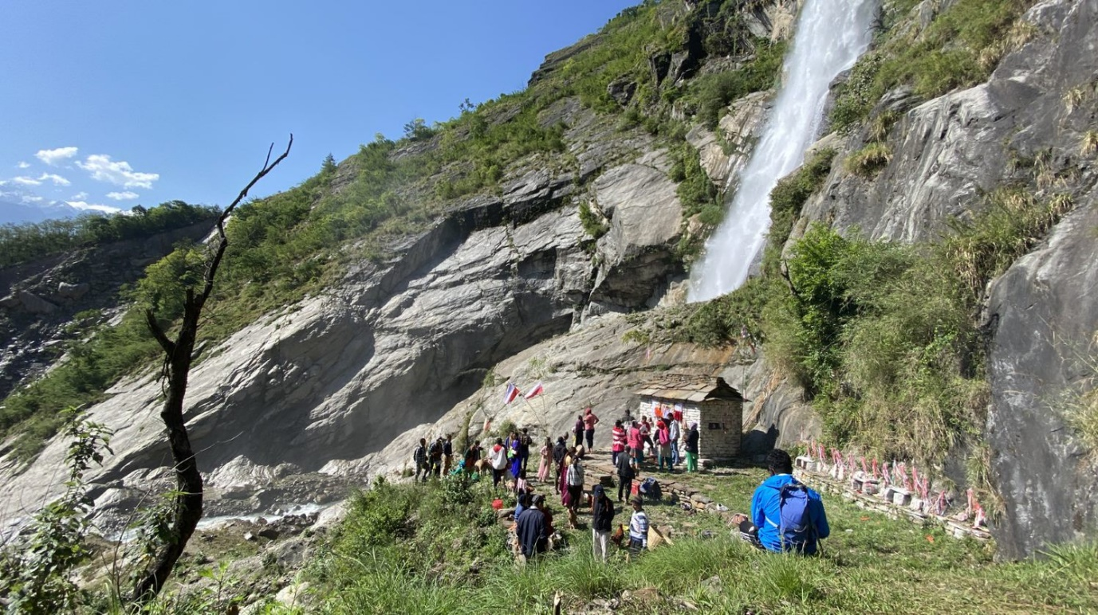
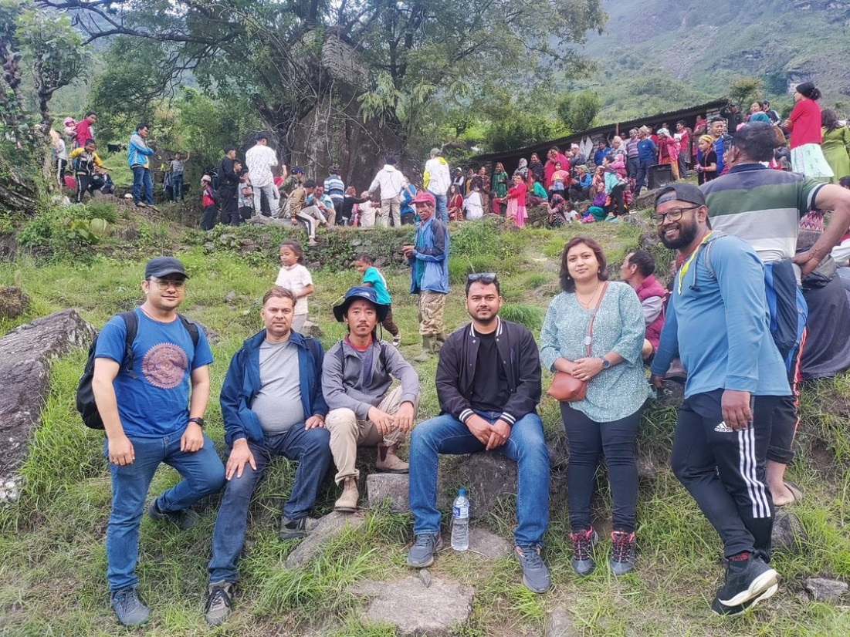

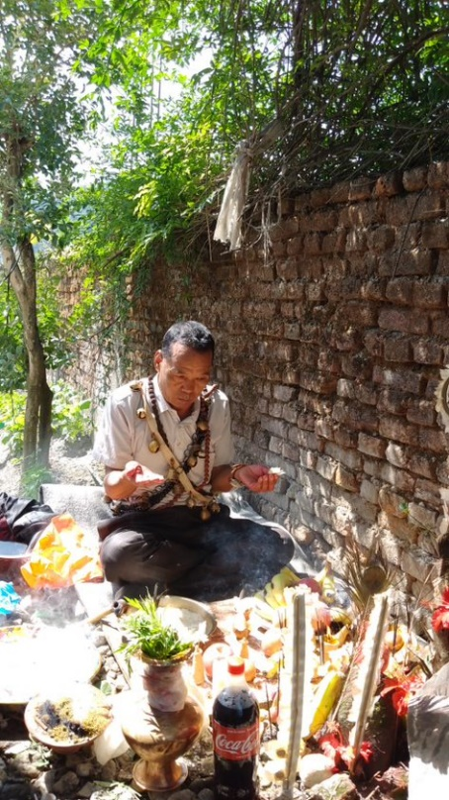

Tek Bahadur Dong attended a bhume puja ceremony held at Mukta Tamang’s home where he observed the rituals and recitations used by Tamangs in the bhume puja. The fieldwork experiences of the RAs will be helpful in creating a deeper understanding of local knowledges about disaster from different community perspectives as well as comparative understanding of disaster governance practice in the case study palikas.

On June 26th, Nyima represented SSB at a Sajag-Nepal presentation for the Ministry of Federal Affairs and General Administration along with team members Sweata and Jimee from NSET and Santosh from IFRCO.
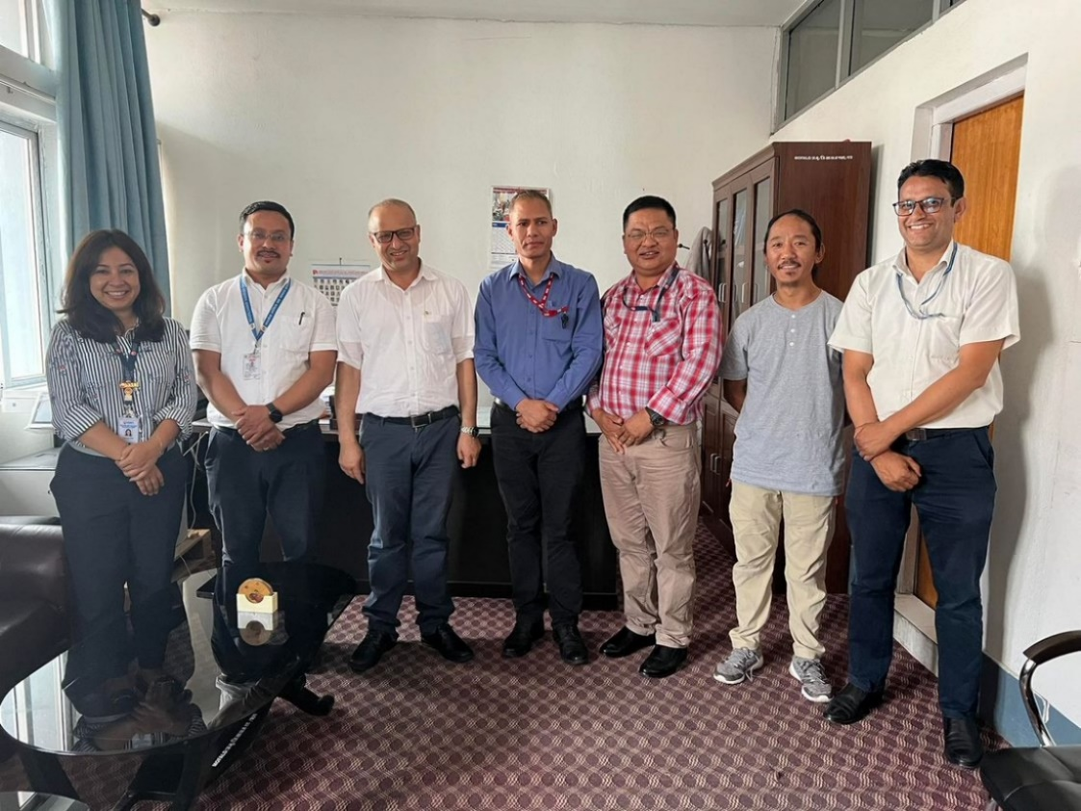

Sajag-Nepal team members attended the 7th Asia-Pacific Dialogue Platform on Anticipatory Action event, and Tek provided this reflection from the event:
Day 1: The ‘7th Asia-Pacific Dialogue Platform on Anticipatory Action’ was held on 13-15 June 2023 at Hotel Radisson, Lazimpath, Kathmandu, Nepal. Hosted by the Anticipation Hub and jointly organized by the German Red Cross, the American Red Cross, the Finnish Red Cross, the Danish Red Cross, the International Federation of Red Cross and Red Crescent Societies (IFRC), the Red Cross Red Crescent Climate Centre, the Food and Agriculture Organization, the United Nations, The UNO office for the Coordination of Humanitarian Affairs, The World Food Program, and Start Network, the program brought nearly two hundred participants from different countries of Asia Pacific Region who were humanitarians, disaster specialists, government representatives, practitioners and private sectors having experiences or interest in the Asia-Pacific Region. The theme was ‘‘Reaching new heights: exploring trails for the sustainable growth of anticipatory action” with objective to foster better anticipatory action to build resilience against disaster and thus, participants were encouraged to share their experiences, lessons related with anticipatory action, forecast-based financing, early earning, disaster risk reduction, community level early warning system, disaster risk financing, and hydrometeorological forecasting, and identify ways to increase sustainability of anticipatory action.
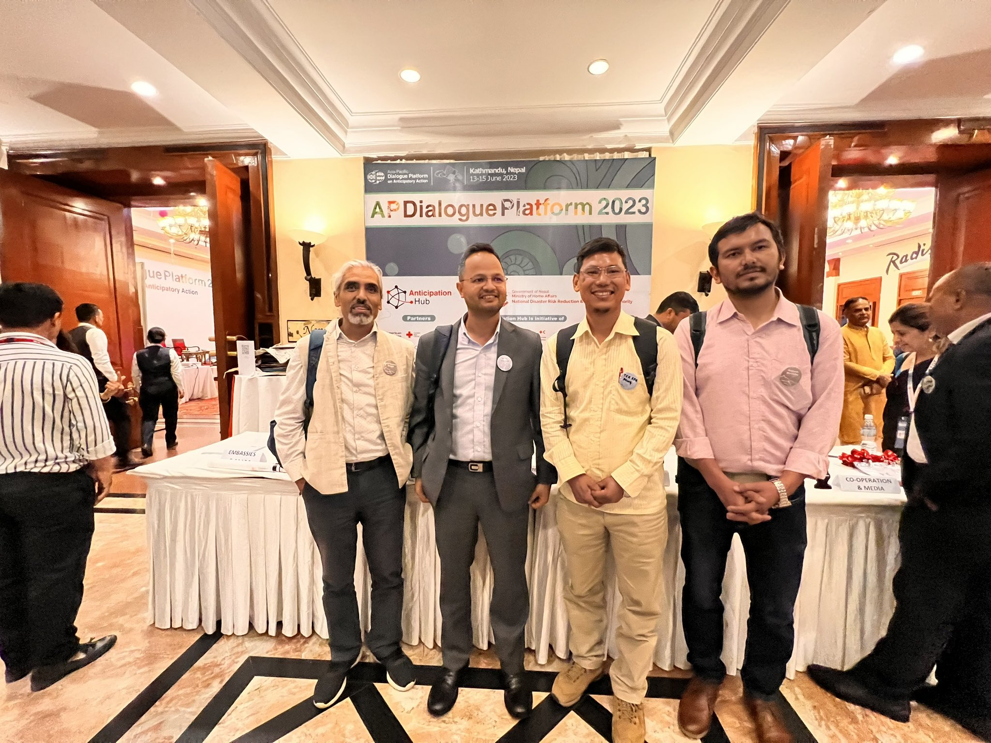
The opening session was chaired by Ms. Kara Devonna Siahaan (the head of Anticipation Hub), Mr. Narayankaji Shrestha (Ministry of Home Affairs), Mr. Anil Pokharel (NDRMA), Mr. Umesh Dhakal (Nepal Red Cross), Mr. Azmat Ulla and Ms Diksha Khadka (IFRC), and Mr. Prem Awasthi (UNRCO). Mr. Naranyankaji Shreshtha shared that anticipatory action is now becoming increasingly accepted and gradually embedded within disaster risk management systems and the federal and provincial government are working on DRR including search and rescue. Mr. Anil Pokharel presented a short video which was about disaster preparedness for the local community with a focus on vulnerable groups.
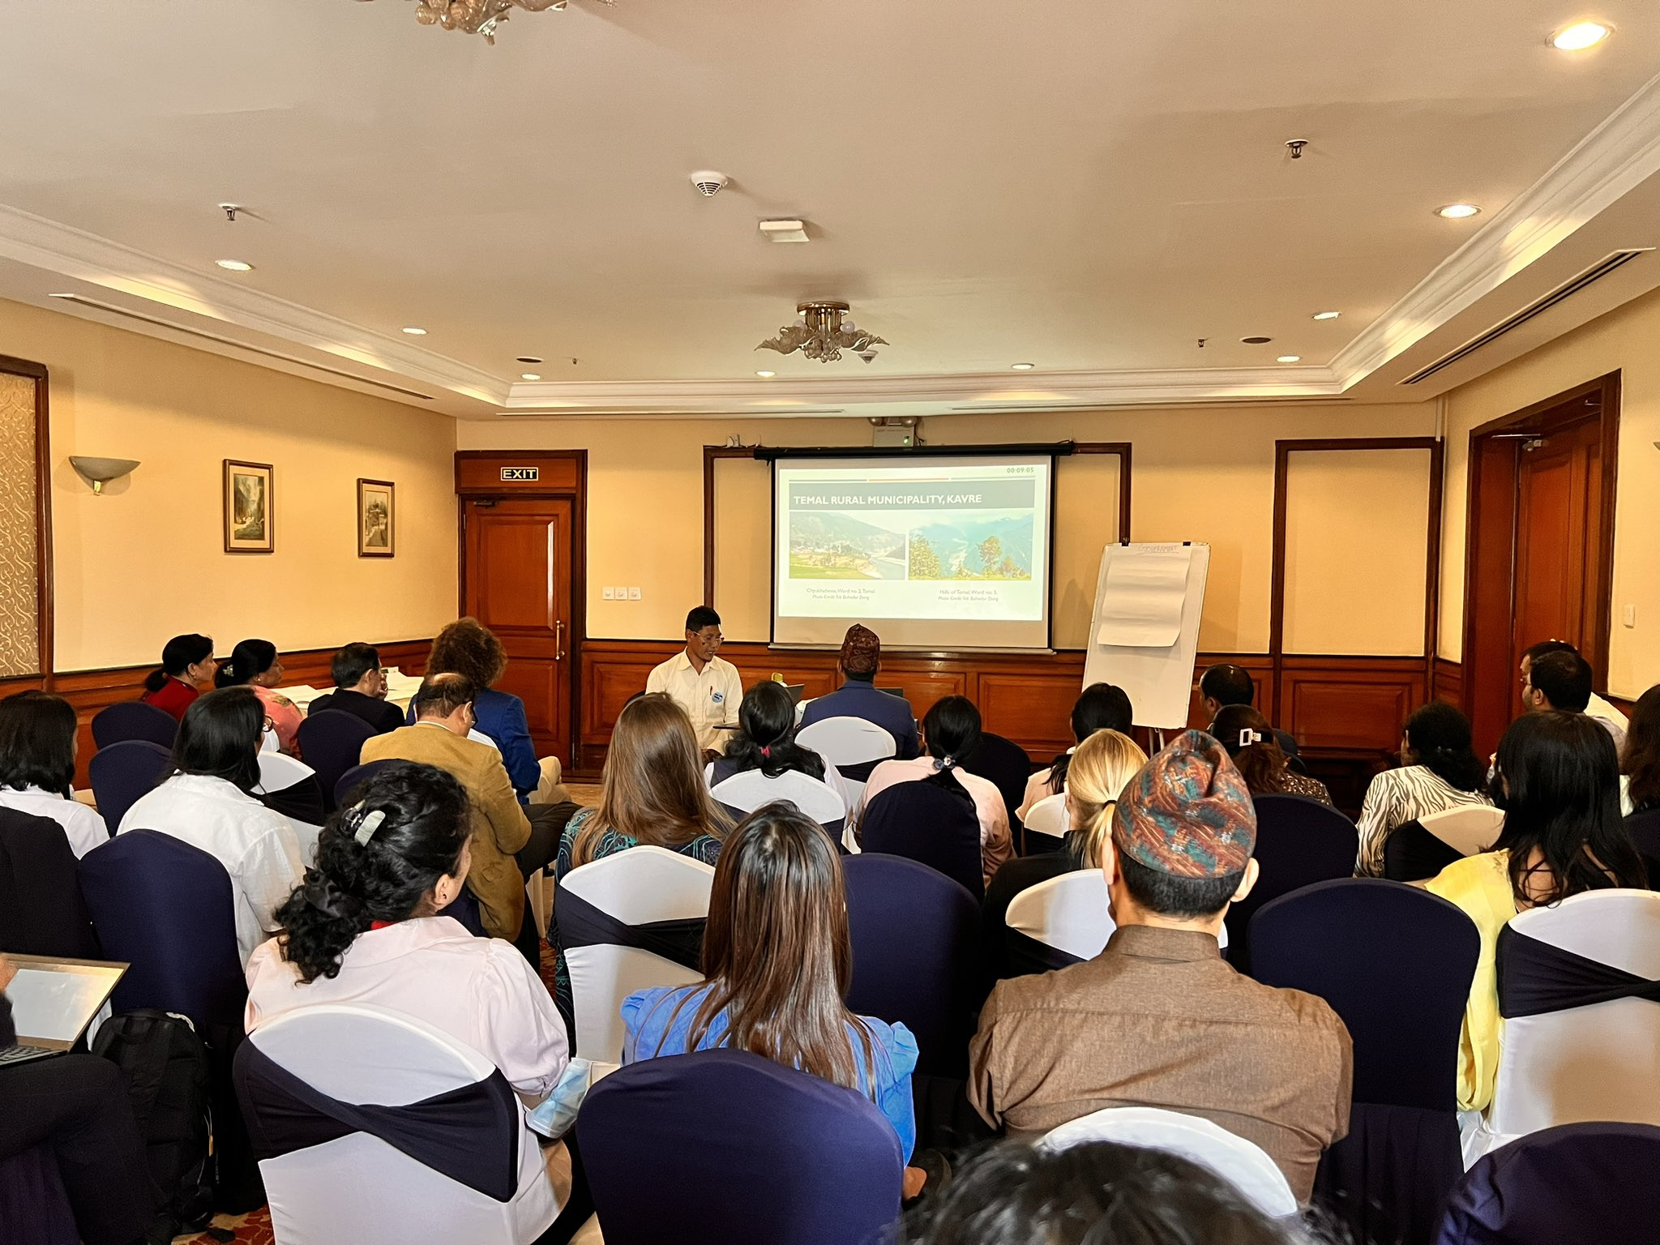
In many of the sessions, the groups were divided into nations belonging to them and gave the opportunity to share their own experiences, good practices, and lessons learned linking with anticipatory projects or their views and ideas. The sessions and workshops were more interactive rather than focusing on presentation. There were also plenary sessions to gather in a single session and discuss the topic given by the program moderator.
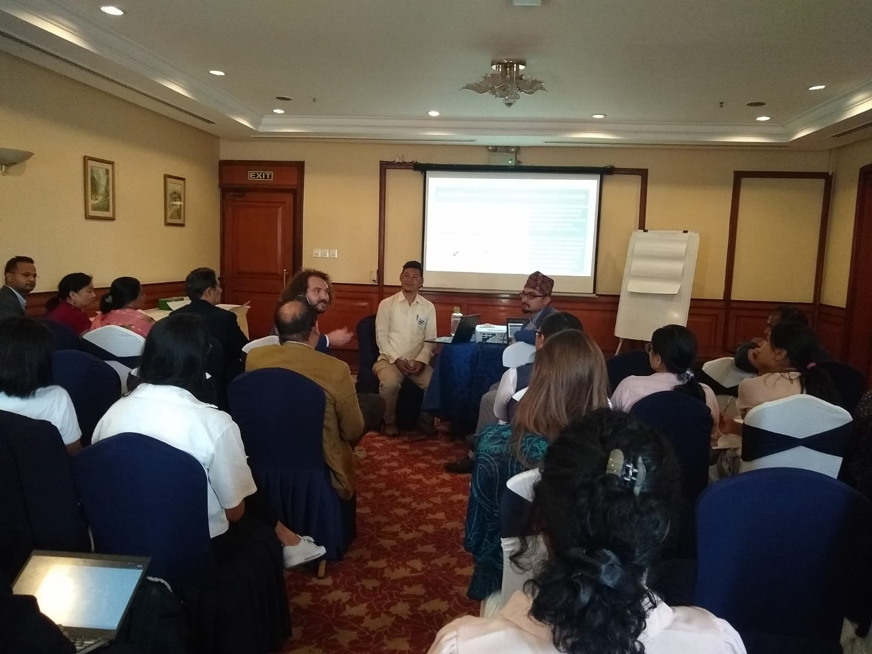
The first day sessions were focused on mainstreaming anticipatory action into government system; empowering indigenous practice, local knowledge and collective action to mitigate disaster; forecasting and climate change; review data of anticipatory action; intergenerational discuss about current gaps and opportunities; and empowering communities with anticipatory action for resilient future. The participants were focusing on public awareness, financial sustainability, private and government engagement, capacity strength, and promoting indigenous knowledge. During local knowledge and indigenous practice session (lead by Tek Bahadur Dong, Niroj Sapkota, and Harold Rice), a Mayer from Janaki Municipality, Kailali, she shared about local knowledge of flood risk and her action plan prior to disaster happen. Mr. Rudra (Nepal Red Cross) reminded the 2nd National Dialogue on Anticipatory Action (11-12 May 2023) and was focused on connecting science and policy with action for communities. He gave a brief overview of anticipatory action in Nepal started in 2018 which was initiated pilot study by Red Cross. In 2019, a first workshop was organized under the leadership of government and community practice forecast based action and shock response carried out in 2020. Mr. Rajendra (NDRMA) recommend for making a small clinic where all expertise of academia, and policy maker fit and sit, and Niru Pradhan (Dennis Red Cross) focuses on a successful dialogue platform collaboration with Red Cross, UN, community practice, and government ownership.
In the final session of the day, presenters from Philippines were emphasizing on anticipatory action through collective actions with national level government, academia and practitioners, donors and local government units, and UN agencies, I/NGOS, CSOs. They were highlighting for local NGOs are the best place navigate local context and scale up anticipatory action through social preparations.
Day 2: The second day program which I attended was about global initiative, synergizing localization of anticipatory action in the middle path and unlocking gender and inclusion in anticipatory action. Participants were bringing a different thoughts as some group keep prioritize funding first then after work/action followed by theory of change, government engagement and set the goal while others focused on government, academician, children and donor and then after work with community and government along with theory of change. Ms Sanchita Neupane (Project Coordinator, People in Nepal, Nepal) was highlighting on the impact of cascading hazard by bringing the example of Phunglingkatti where 5 members of the same family lost their life by monsoon debris in Sindhuplachowk. Participants from Bangladesh shared that local people identify the risk, prepare plan accordingly and inform to government. In the case of Philippines, local government identify the risk and then address it. They involve the local community in the planning process.
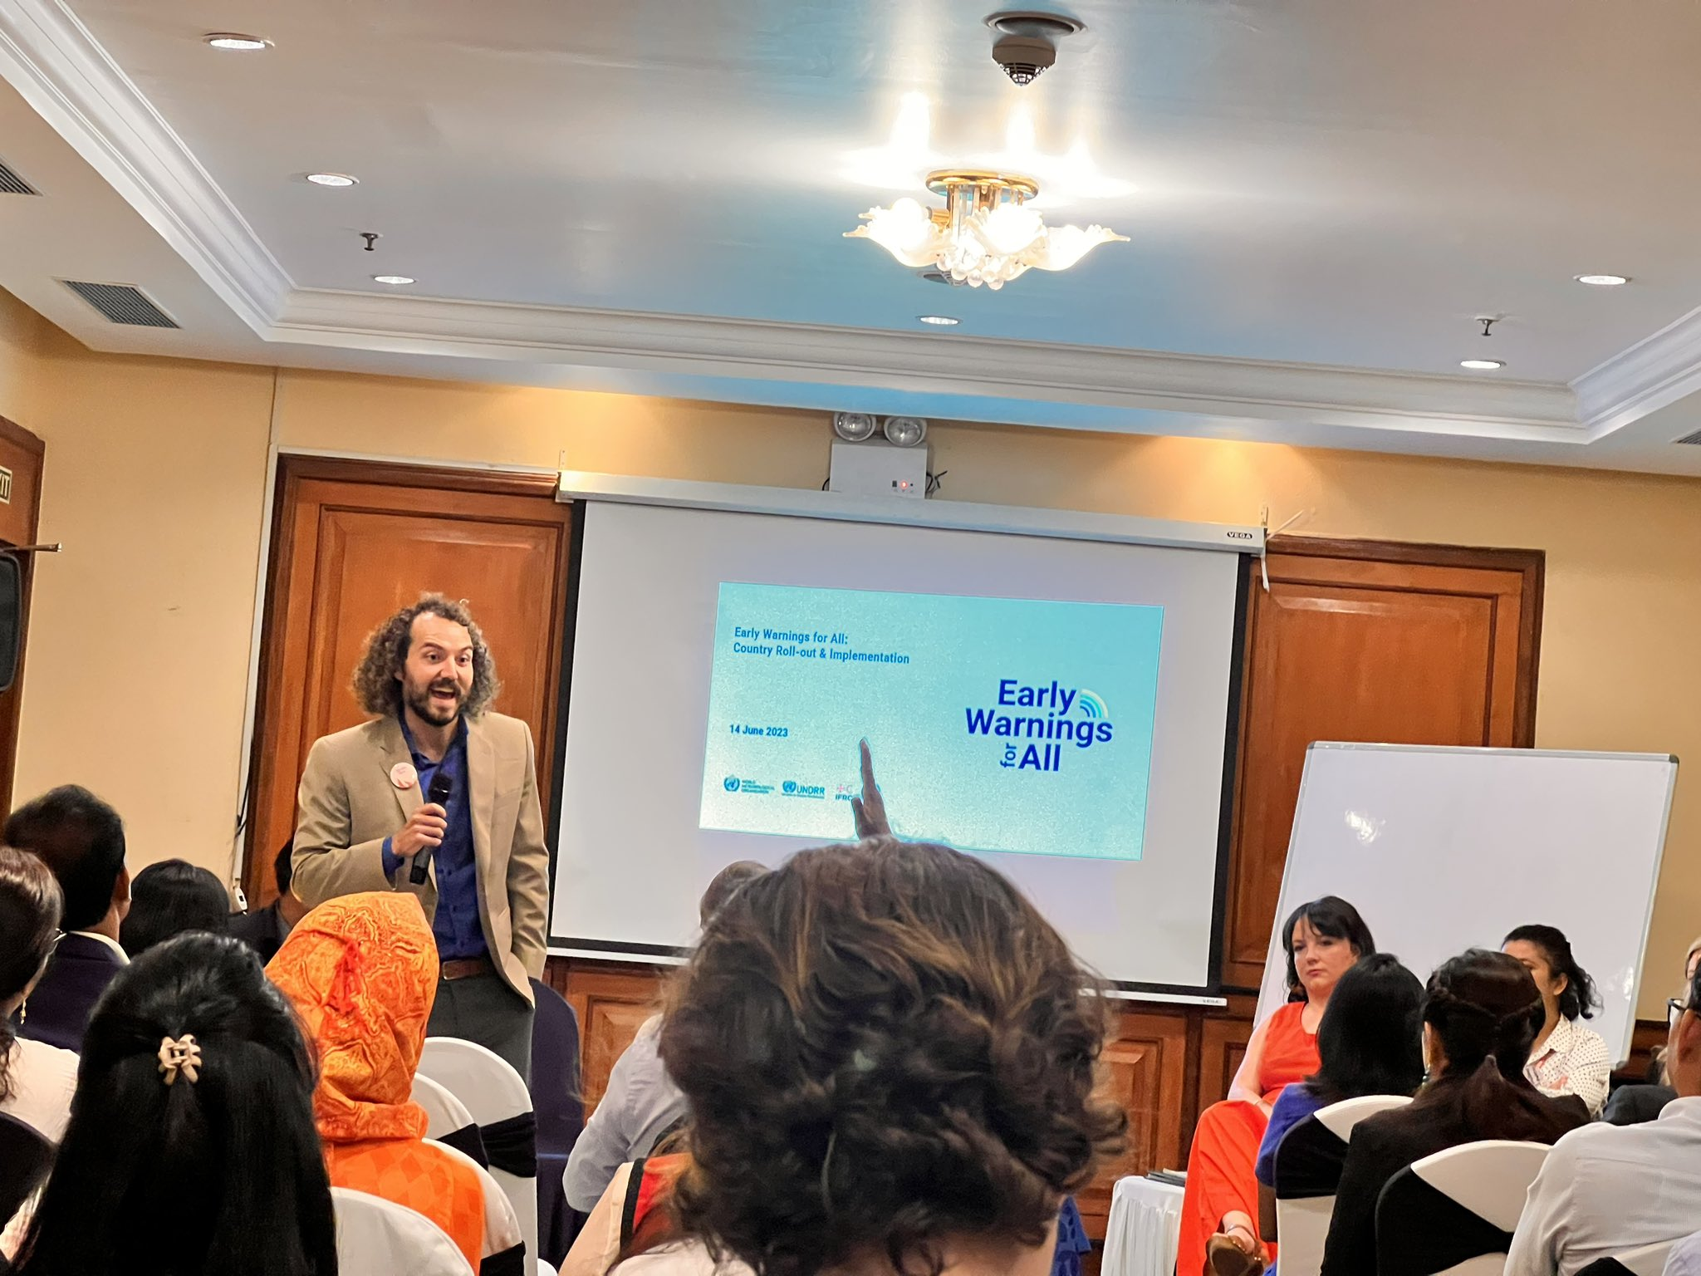
In the session of “empowering tomorrow”, the presenters from Sri Lanka, Indonesia, and Mongolia were focusing on women issues and vulnerable groups which were primarily discussed around the issue of access, participation, decision making, and well-being. Therefore, it was recommended for working with children to understand the sense of disaster, more awareness program for vulnerable group, empowering to women through gender equality and social inclusion.
Day 3: The 3rd and last day of the program began with some of the key questions among the groups such as vision in next five years along with the current gaps and challenges, the key goal, and activities, and how to ensure sustainability. Each representative from the table had different answers including institutional capacity development, strengthening regional cooperation for all multi hazards, public and private engagement, regional and global platform for disaster and climate, dedicate funding for most vulnerable communities, risk transfer, index-based insurance, social safeness and advocate and sensitization for increase allocation for anticipatory action by government, donor and private sector and some of these issues were also highlighted by the Mr. Ganga Lal Tuladhar, . In the mid sessions, there were pictures of disaster events that happened in different landscapes and participants were requested to observe and identify weakness. Some of these lack of green vegetation in terrace slope hill, some settlements were developed in the river corridor while next picture illustrated about the very short suspension bridge which most likely wash away by the monsoon flood.
The last session was ended with some recommendations. Participants were arguing that disasters happened at the local level, but funds are allocated from the central level. Thus, some key suggestions for annual national budget were: i) should have a flexible fund to use in anticipatory action for multi-hazard, ii) national plan and subsidiary plan need to be updated, iii) budget allocation for training, capacity building, and research, iv) establishment of public private partnership, and v) anticipatory action to be institutionalized by the law as one of the keys DRM policies of the country.
Katherine represented the Sajag-Nepal team at the first Critical Geographies of Disasters workshop at the University of Reading on the 27th June. This new event was organised by Dr Sophie Blackburn and Dr Simon Dickinson and was both a research workshop and launch event for the new Critical Geographies of Disasters network. The workshop had a number of invited speakers who were tasked with discussing the future directions and challenges of disaster research. The presentations were very thought provoking, where speakers both reflected on their own research to date and sketched new conceptual frameworks for the future. The workshop was well attended by key researchers within the field and themes discussed included the temporality of disasters, local and indigenous knowledges and transformative change as well as focused discussions around ‘What defines/delineates a ‘critical’ approach to disasters?’, ‘What is the significance of ‘geographical’ perspectives in disasters research? Is this focus a strength or a distraction?’ and ‘How central is the idea of ‘transformation’ to ‘critical geographies of disasters’?’. The newly launched network aims to both have sponsored sessions at conferences and plans to coordinate an edited book: The Critical Geography of Disasters.
Work Packages 2 and 3
Alex Dunant has been continuing to develop and refine the multi-hazard risk model over the last few months. He has now completed the switch from a more usual network model – which is based on paired relationships between the hazards and the elements that are exposed to those hazards – to a much more efficient hypergraph model, where hazards and elements can be grouped together. This has sped up the model significantly and means that it can be run effectively at a national scale. Preliminary results from the model, focusing on impacts from the earthquake scenario ensemble, were shared with the Humanitarian Country Team in April, and Alex’s focus now is on extending the model to monsoon scenarios so that it can underpin contingency planning.
One of the outstanding issues in any model of monsoon-related hazards is in deciding on an appropriate trigger – in other words, how much rainfall is needed to set off events in the hazard cascade? Much of the prior work on this problem has tried to define a threshold based either on cumulative rainfall or on a combination of cumulative rainfall and the intensity of that rainfall (i.e., how much rain falls in a particular period of time). The problem is that those thresholds don’t work for all situations, and are very hard to scale up beyond a local area. Alex, Sihan, and Max have been working with Kelsey Doerksen, a specialist in machine learning at Oxford, to explore alternative ways of defining that trigger. Kelsey has used landslide events in the BIPAD portal to evaluate the combination of factors, like rainfall totals and soil moisture, that best explain landslide occurrence. Her model works surprisingly well at district scale – that is, given a particular set of circumstances it can predict when landslides are likely to occur within a certain district. She’s now in the process of evaluating whether that can be extended down to palika scale, to give us a more detailed picture of where landsliding is likely to occur. This can then be used to ‘target’ the multi-hazard risk model, so that we can develop a picture of the potential impacts from that landsliding. There is plenty of work to do still on this approach, including understanding how reproducible it is as well as the impact of using rainfall forecasts rather than observed rainfall for anticipating landslide occurrence.
Meanwhile, Max has extended his slow landslide mapping approach to a national scale. We are planning to discuss this work with the Department of Mines and Geology, who have previously expressed interest in understanding and monitoring large slow-moving landslides around the country. Max has also been analysing the relationship between the different types of impacts caused by landslides in comparison with other hazards, using both a global dataset as well as some Nepal-specific information. He has found that there is little correlation between the number of people killed in an individual landslide and the number of buildings that are damaged. This is in strong contrast to other hazards like earthquakes, where events that damage a lot of buildings also tend to result in large numbers of deaths. This is an important result for thinking about how we model landslide impacts, because the typical approach of using buildings as a good proxy for where people will be – and thus how many people will be affected by a given event – is probably not very helpful.
Next week members of the project team will meet to start planning for the next round of workshops with the Humanitarian Country Team in September. A key goal of those workshops will be to share results from the updated multi-hazard risk model with the clusters, using the seasonal monsoon forecast as a basis for discussion and comparing the model outputs with experiences of what actually happened.
Work Package 4
Sajag-Nepal team members prepared a set of key messages around monsoon preparedness that were shared with NDRRMA in May. Gopi very kindly provided an initial translation of the messages into Nepali. BBC Media Action is now moving ahead with the production of messaging related to floods and landslides with Radio Nepal and regional media partners, which includes translation into other local languages besides Nepali and dissemination through radio and social media.
BBC Media Action has also been busy with video and production of the two short documentary films that are currently being prepared, and has been continuing to support regional partner radio stations in each of the seven provinces around their disaster and contingency planning. They are starting to develop plans to interview officials from NDRRMA and other relevant government bodies to augment the content. They are also prepared to support the upcoming Sajag-Nepal meeting in September in Kathmandu, including facilitation of panel discussions and all communications and media support.
Research ethics
The Sajag-Nepal project has undergone ethical review at Durham University and we have received approval to begin the research. A copy of the documentation (including a project risk assessment) is available via OneDrive for the team to access. As previously discussed, this is very much a live document and work package leads will be responsible for updating and resubmitting amendments as required, and as the research evolves. A big thank you to everyone who fed into this process. Any questions, please contact Katie: katie.oven@northumbria.ac.uk

Social media
Sajag-Nepal is active on Twitter (@SajagNepal) and our project website (www.sajag-nepal.org) is fully open for blog posts and reports. If you would like to tweet or post to the website, please contact Rachel for login details. We also feature on the recently relaunched Radix website (Radix: Radical Interpretations of Disasters), as an example of a project with its own ethical guidelines which build on the principles of the Disaster Studies Manifesto: Power, Prestige and Forgotten Values. It is worth noting that Tek took over the Radix Twitter feed from 12-18 June, so please see his posts at @DisastersRadix.
Alex Dunant has started a project Slack platform and several team members are active on Slack – if you are interested in exploring this as a way to communicate across the project, please contact Alex directly (alexandre.dunant@dur.ac.uk).
We are trialling a move from Google Drive to OneDrive for general project materials and information. We have started this with materials for our monthly team meetings, and if there are no access issues then we will extend this to other documents as well. Please contact Rachel if you have any questions or concerns.
Project communication guidelines have been developed with input from the WP leads, with guidance for good practice and things to consider when communicating about the project. This is available on the project OneDrive and Google Drive. We will continue to update and refine this, so please send any suggestions to Rachel.

Recent publications
If you have recently published a paper or other output that is relevant to Sajag-Nepal, please send the details to Rachel and we will list them here for the team to see. Please include the DOI and a link to any open-access version, if possible.

